Network Devices & Local Area Network (LAN)

Introduction
A network device is a hardware component used to connect computers, servers, printers, and other electronic devices to form a communication network. These devices enable communication by transmitting, receiving, routing, and managing data across the network.

1. Network Interface Card (NIC)

Definition
A Network Interface Card (NIC) is a hardware component that allows a computer to connect to a wired or wireless network.

Features
- Operates at Layer 1 (Physical) and Layer 2 (Data Link).
- Has a unique 48-bit MAC Address assigned by the manufacturer.
- Available in Ethernet (wired) and Wi-Fi (wireless) versions.
- Converts digital data into electrical, optical, or wireless signals.

Advantages
- Enables communication between computers.
- Provides high-speed network connectivity.
- Supports both wired and wireless networking.
- Does not reduce network congestion.
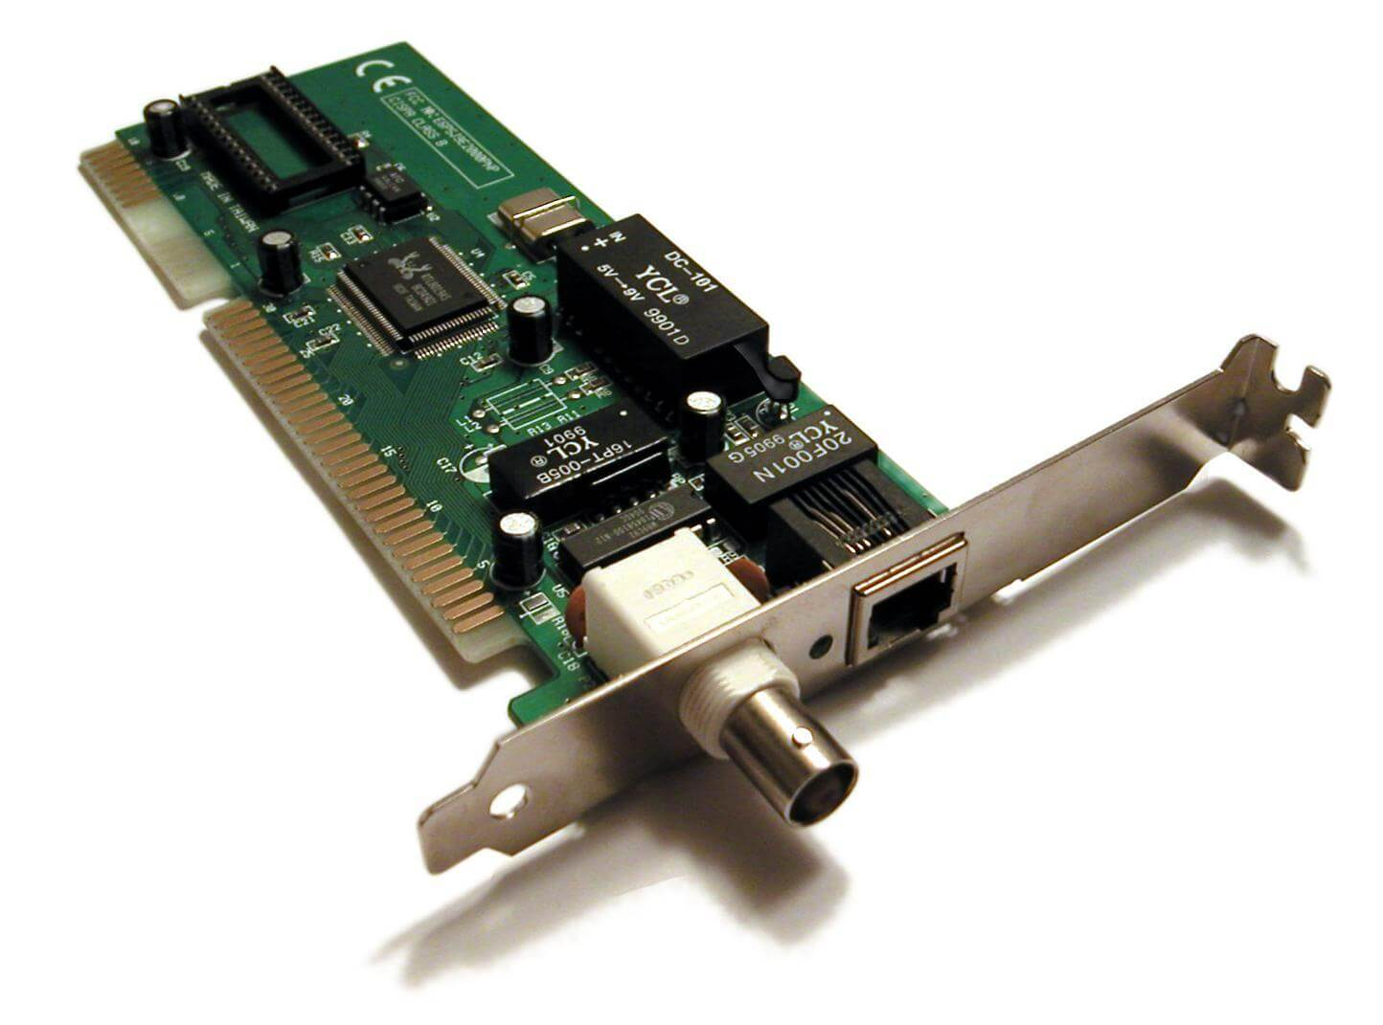

2. Repeater

Definition
A Repeater is a networking device that regenerates weak signals and retransmits them over longer distances.

Features
- Operates at Layer 1 (Physical).
- Regenerates weak signals.
- Does not inspect data or addresses.
- Usually has two ports.

Advantages
- Extends network coverage.
- Improves signal quality.

Disadvantages
- Cannot filter traffic.
- Does not reduce network congestion
.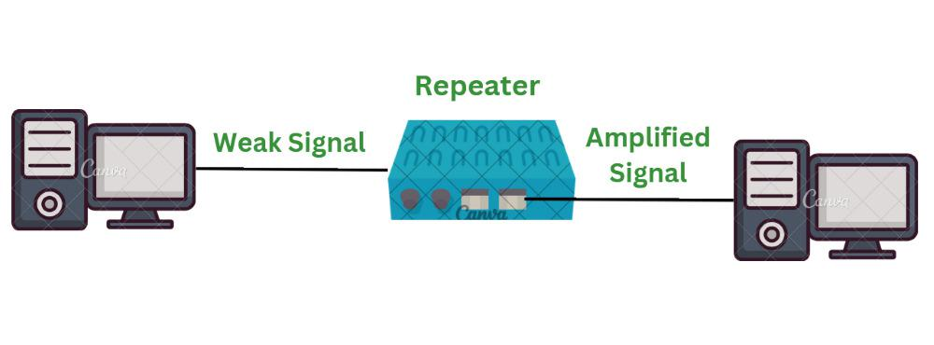
3. Hub
Definition
A Hub is a multi-port repeater that broadcasts incoming data to all connected devices.
Features
- Operates at OSI Layer 1 (Physical Layer)
- Broadcasts data to every connected device
- Single collision domain
- Single broadcast domain
- Supports half-duplex communication
Advantages
- Low cost
- Easy to install
- Simple to use
Disadvantages
- Causes frequent network collisions
- Low performance
- No security or traffic filtering
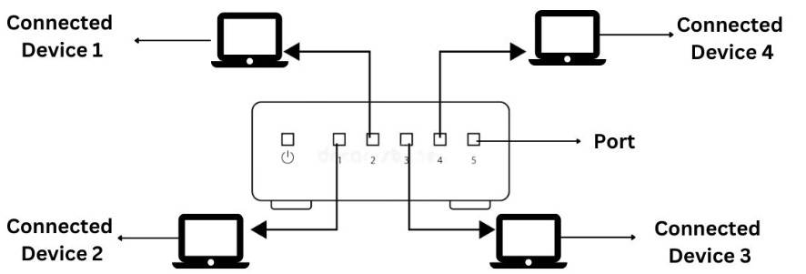

4. Bridge
Definition
A Bridge connects two LAN segments and forwards frames using MAC addresses.
Features
- Operates at OSI Layer 2 (Data Link Layer)
- Learns MAC addresses
- Filters unnecessary traffic
- Reduces collisions
- Connects two LAN segments
Advantages
- Improves network performance
- Reduces unnecessary traffic
- Decreases collisions
Disadvantages
- Supports only a limited number of LAN segments
- Slower than modern switches
- Becoming less common 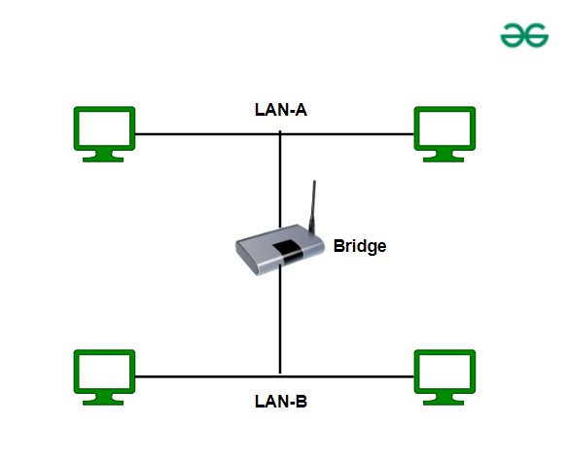

5. Switch
Definition
A Switch is a multi-port bridge that forwards data only to the destination device using MAC addresses.
Features
- Operates at OSI Layer 2 (Data Link Layer)
- Uses a MAC Address (CAM) Table
- Supports full-duplex communication
- Each port has its own collision domain
- Single broadcast domain (unless VLANs are configured)
Types of Switches
- Unmanaged Switch
- Managed Switch
- PoE (Power over Ethernet) Switch
- Layer 3 Switch
Advantages
- High-speed communication
- Reduces collisions
- Efficient bandwidth utilization
- Improves network performance
Disadvantages
- More expensive than hubs
- Managed switches require configuration
- Broadcast traffic still exists without VLANs 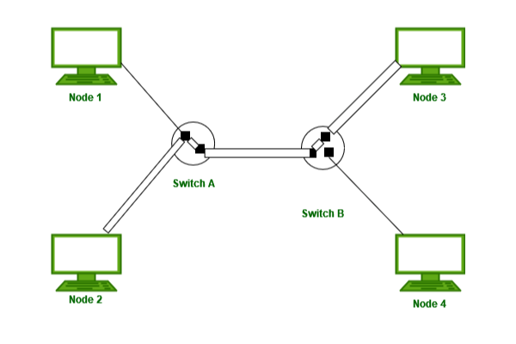

6. Router
Definition
A Router connects different networks and forwards packets using IP addresses.
Features
- Operates at OSI Layer 3 (Network Layer)
- Uses IP addresses for routing
- Maintains routing tables
- Performs Network Address Translation (NAT)
- Connects LANs to WANs or the Internet
Advantages
- Connects multiple networks
- Separates broadcast domains
- Provides Internet connectivity
- Supports security features like ACLs and firewalls
Disadvantages
- Higher cost
- More complex configuration
- Slower than switches for local traffic 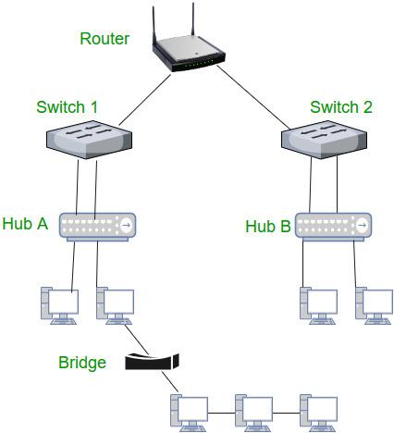

7. Gateway
Definition
A Gateway connects networks using different communication protocols and acts as a protocol translator.
Features
- Operates across multiple OSI layers (commonly Layer 7)
- Performs protocol conversion
- Connects different network architectures
- Often integrated with routers
Advantages
- Enables communication between different protocols
- Supports protocol translation
- Allows interoperability between dissimilar networks
Disadvantages
- Expensive
- Complex to configure and maintain
- 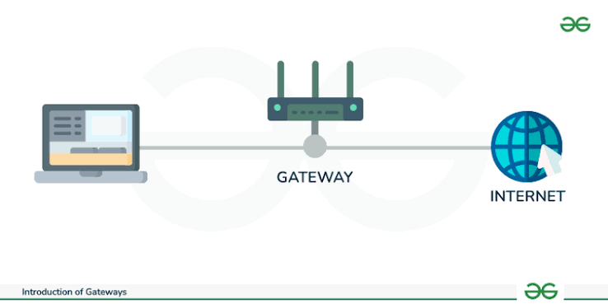

Comparison of Network Devices
Device | OSI Layer | Forwarding Based On | Collision Domain | Broadcast Domain
Hub | Layer 1 | Signal | One (Shared) | One
Bridge | Layer 2 | MAC Address | One per Segment | One
Switch | Layer 2 | MAC Address | One per Port | One
Router | Layer 3 | IP Address | One per Port | One per Interface

Local Area Network (LAN)
Definition
A Local Area Network (LAN) connects computers and devices within a limited geographical area such as a home, office, school, or campus.
Characteristics
- High-speed communication
- Low latency
- Privately owned
- Reliable
- Secure
- Easy to maintain

LAN Topologies
1. Star Topology
All devices are connected to a central switch or hub.
Advantages
- Easy to install and manage
- Failure of one device does not affect others
- Easy troubleshooting
Disadvantages
- Failure of the central switch stops the network
- Requires more cable

2. Bus Topology
All devices share a single backbone cable.
Advantages
- Low installation cost
- Simple design
Disadvantages
- Backbone failure affects the entire network
- Difficult to troubleshoot
- Performance decreases with more devices

3. Ring Topology
Devices are connected in a circular loop.
Advantages
- No data collisions (using token passing)
- Equal access for all devices
Disadvantages
- Failure of one device or cable can break the network
- Difficult to expand

4. Mesh Topology
Every device is connected to every other device.
Advantages
- Highly reliable
- Multiple communication paths
- Excellent fault tolerance
Disadvantages
- Expensive
- Complex installation
- Requires many cables
- 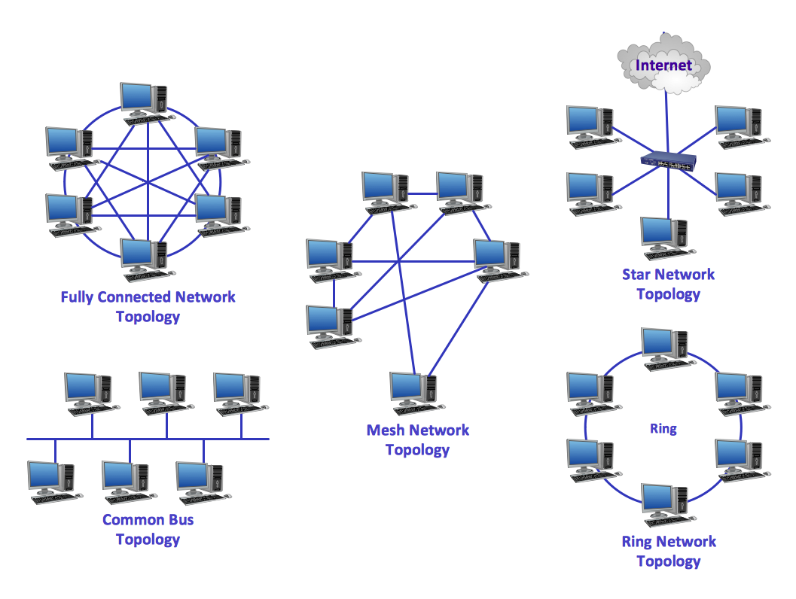

LAN Components
Component | Purpose
Switch | Connects computers in the LAN
Ethernet Cable | Transfers data
RJ45 Connector | Connects Ethernet cables
NIC (Network Interface Card) | Connects a computer to the network
IP Address | Identifies each device
Subnet Mask | Identifies the network and host portions

Private IP Address Ranges
Class | Range | Default Subnet Mask
A | 10.0.0.0 – 10.255.255.255 | 255.0.0.0
B | 172.16.0.0 – 172.31.255.255 | 255.255.0.0
C | 192.168.0.0 – 192.168.255.255 | 255.255.255.0

Example LAN Configuration
Computer | IP Address | Subnet Mask
Computer 1 | 192.168.1.10 | 255.255.255.0
Computer 2 | 192.168.1.11 | 255.255.255.0
Computer 3 | 192.168.1.12 | 255.255.255.0

Testing Connectivity – Ping Command
Definition
The ping command tests connectivity between two devices on a network.
Syntax
ping <IP_address>
Example
ping 192.168.1.11
If the destination device is reachable, the command returns Reply messages along with the Round-Trip Time (RTT).

Advantages of LAN
- High-speed data transfer
- Easy resource sharing
- Cost-effective
- Centralized management
- Improved communication
- Easy maintenance

Disadvantages of LAN
- Limited geographical coverage
- Initial installation cost
- Requires maintenance
- Security risks if not properly configured

Conclusion
Network devices such as NIC, Repeater, Hub, Bridge, Switch, Router, and Gateway play a vital role in computer networking. Among these, the Switch is the most widely used device in modern LANs because it forwards data efficiently using MAC addresses, reducing collisions and improving performance. A LAN provides fast, reliable, and secure communication within a limited area, making it ideal for homes, schools, offices, and organizations.
Corrections made:
- Corrected "Router: Broadcast Domain = Per Port" to "Per Interface" (more accurate terminology).
- Added a note that a switch has a single broadcast domain unless VLANs are configured.
- Improved grammar, consistency, and exam-friendly formatting.
- Added a few important points (security, bandwidth utilization, fault tolerance, troubleshooting) for more complete notes.

